Assignment 02

Name: Sarthak Niranjan Kulkarni

Roll No.: T211075

Div: A

Aim: Assignment to install and configure Google App Engine steps:

Installation Process

Make sure that Python is installed in your system.

Search “Google Cloud” on your browser andopen the link as shown in fig.

Select “Cloud SDK” tab.

Click on gcloud CLI to install Google SDK CLI

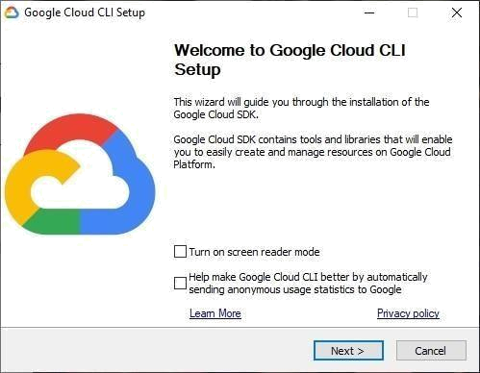
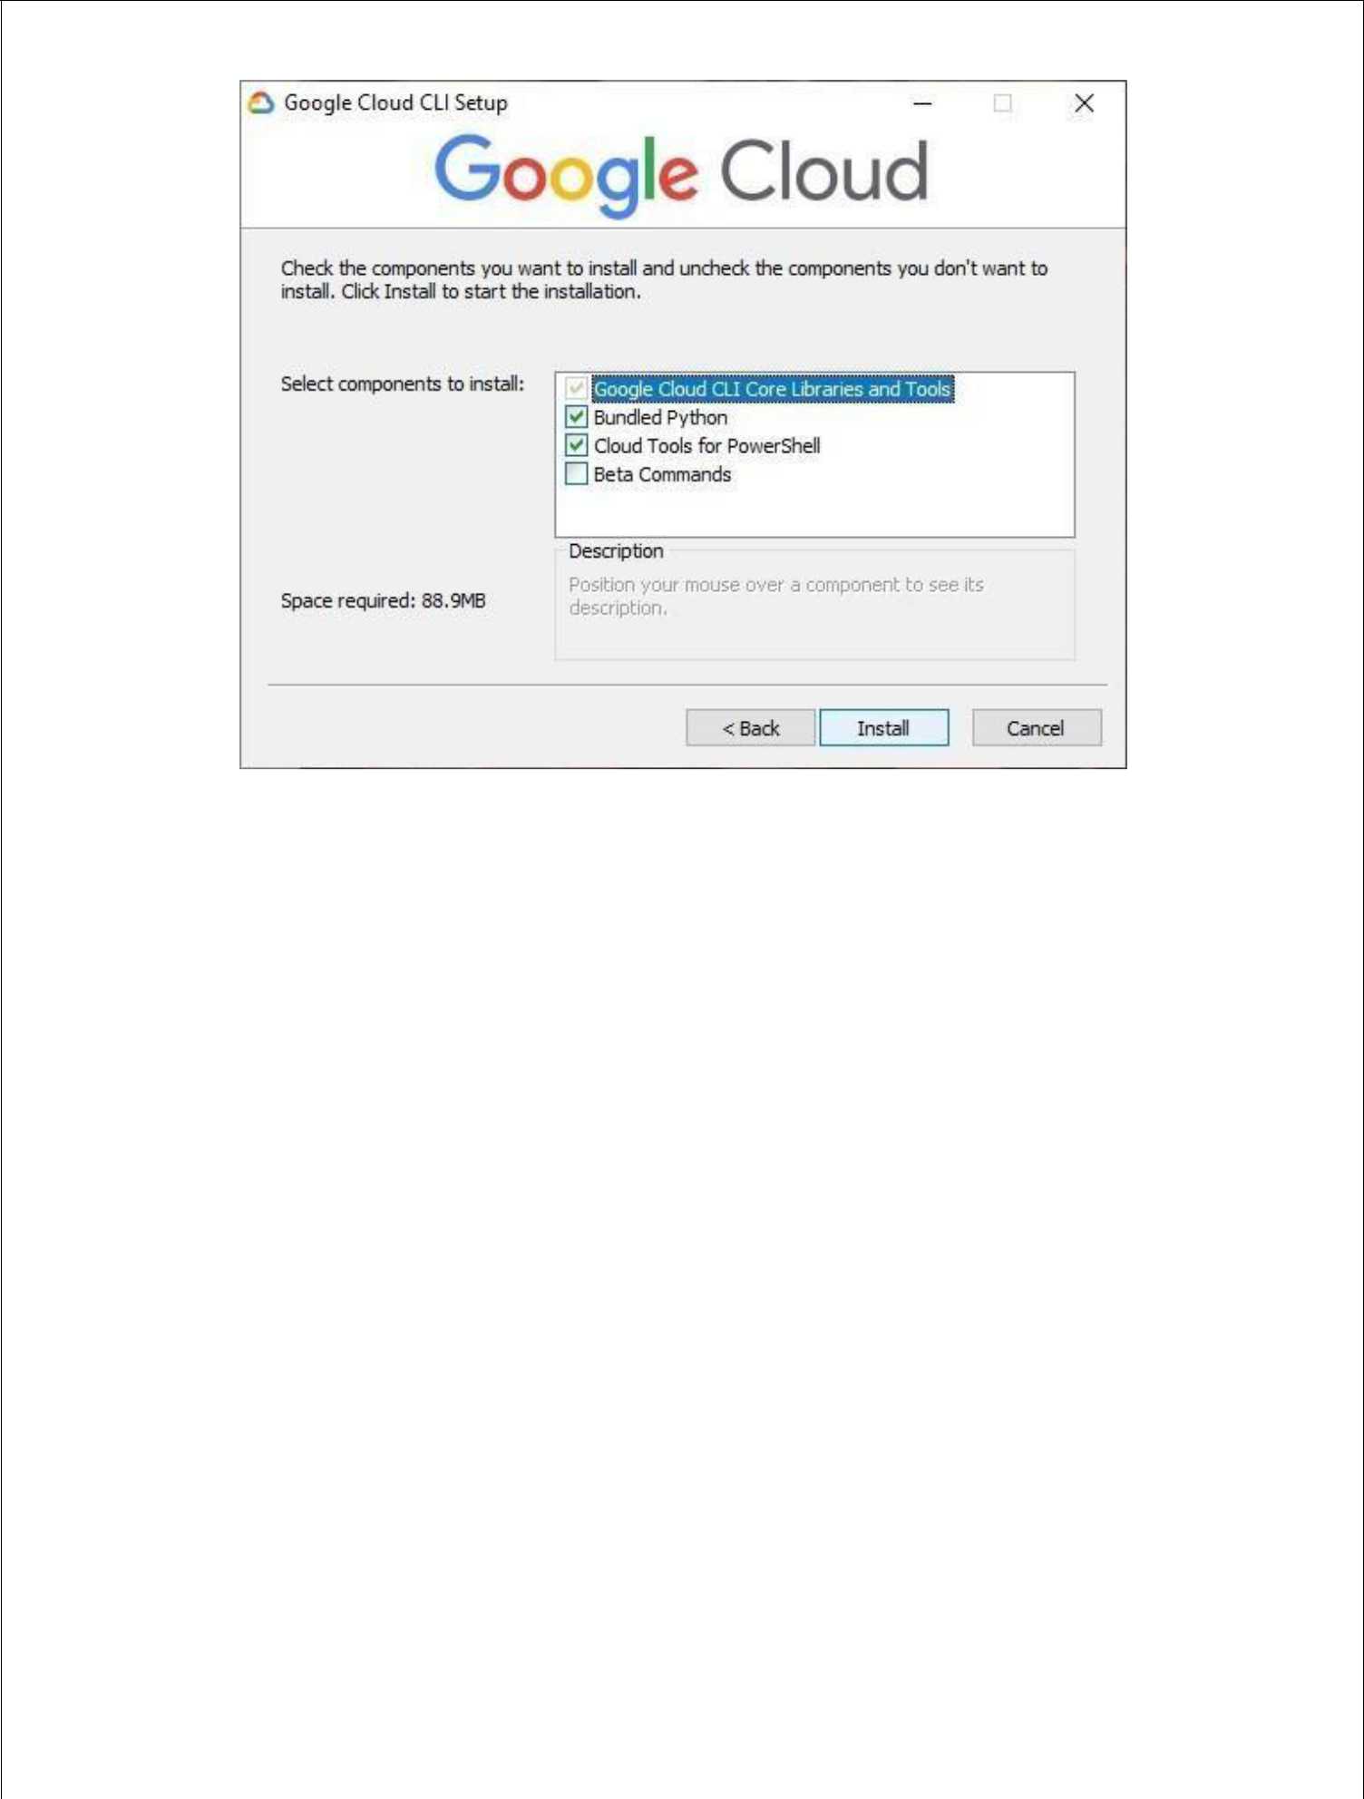

Click on Finish to start the Google Cloud SDK Shell or open the application “Google Cloud SDK Shell” and type “gcloud in it” command to begin the process.

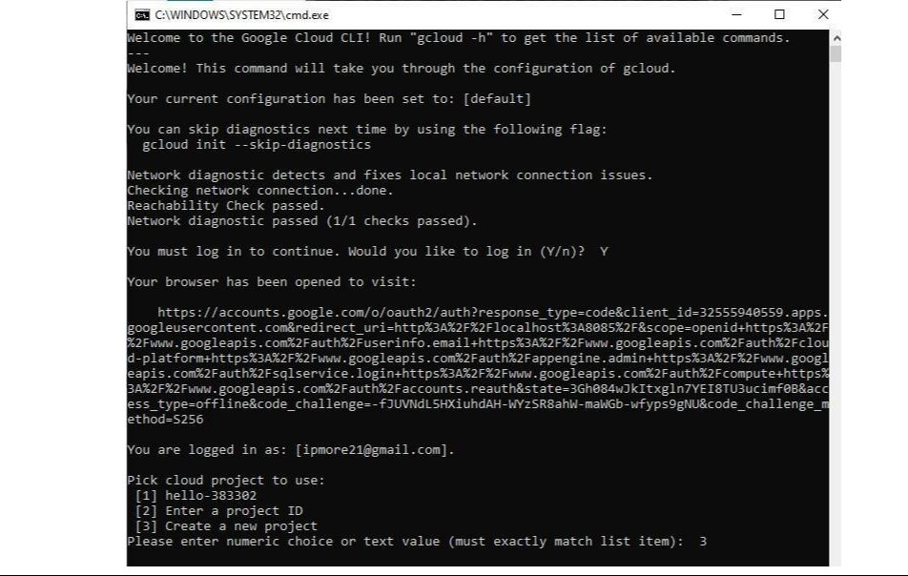
Choose 2nd option for “Creating a new configuration” or1st option for choose the “default settings” from fig.shown below.

Now choose account to login. If not logged in earlier you’ll be redirected to your browser for login with your google account. Enter the credentials.

Click on “Console” and open cloud shell editor.

Create New file ‘name.py

Type the code. Click on ‘Run’ menu tab.

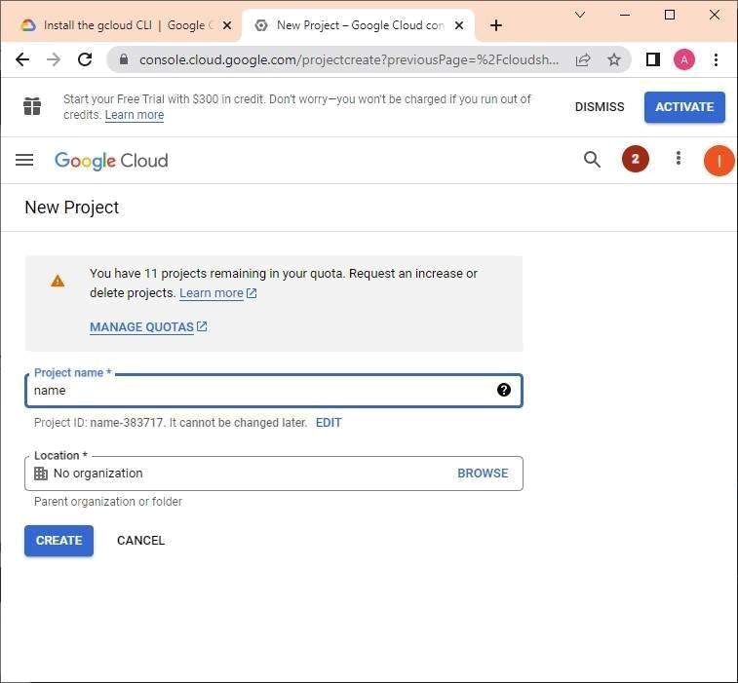
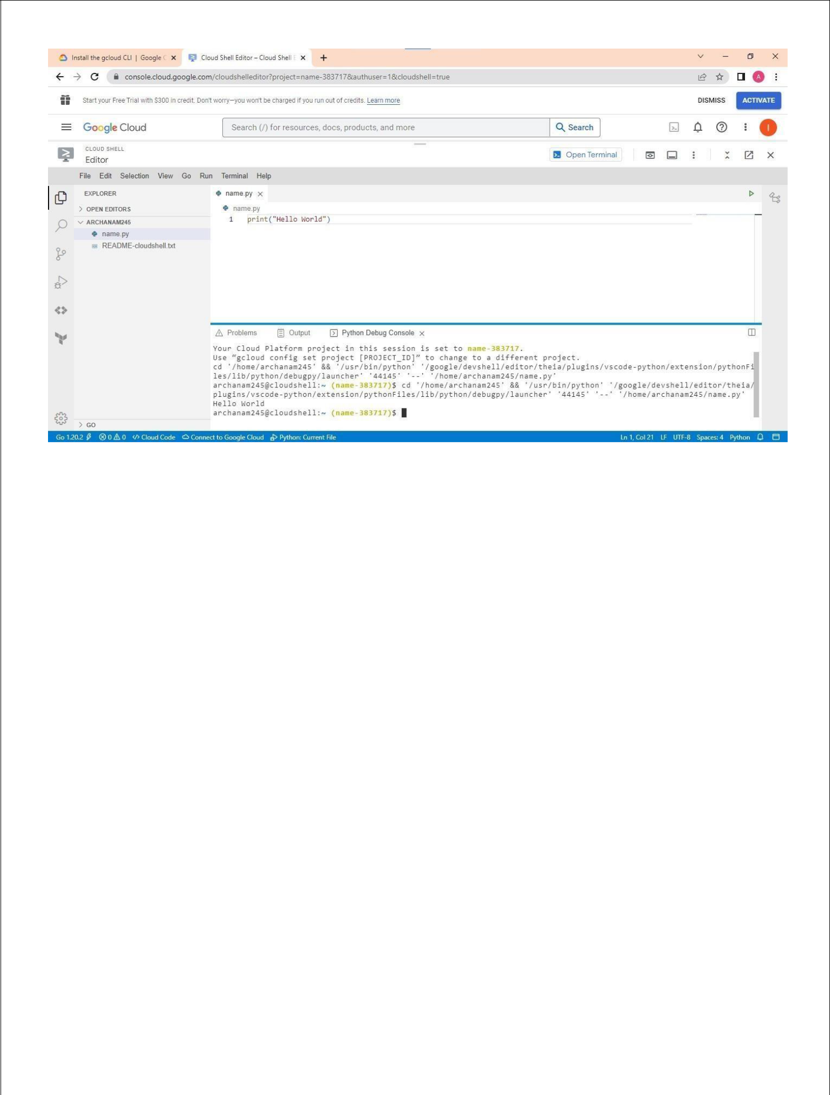

Click on “Start without debugging” if you want to run without debugging the program.

Proceed with default configurations.

You have successfully deployed python app.

